Menstrual formula

CHANGE THE WAY YOU THINK
ABOUT YOUR PERIOD
- Help reduce mild menstrual cramps*
- Support healthy blood flow*
- Support urinary tract health*
- Support healthy libido*
- Support hormones leading up to ovulation*
- Support thyroid health*
- Promote clear looking skin*
- Reduce normal symptoms of PMS*
- Reduce occasional stress*
- Balance mood*
- And more!
Scientifically formulated with:
- Menstrual D-Tox Complex™
- Bio-Optimal Pre-Ov Blend™
- Co-Active PMS Matrix™

Formula #1 - Period: Days 1-4 (Release Phase)

BENEFITS
FORMULATED WITH INGREDIENTS SHOWN TO:
- Help relieve mild discomfort associated with menstrual cramps*
- Ease occasional and mild bloating, nausea, cramping and loose stools*
- Support the body’s natural detoxification process*
- Promote clear looking skin*
- Support healthy blood flow*
- Support iron metabolism*
- Support liver health*
- Support urinary tract health*
- Support antioxidant capacity*
- Support energy levels*

FEATURES
- A proprietary blend of potent, synergistically paired herbs, essential nutrients, botanicals and antioxidants to support hormones during your period*
- Clean label formula
- Hormone- and soy isoflavone-free
- Gluten-free
- Dairy-free
- Non-GMO

Formula #2 - Follicular Phase: Days 5-16 (Renew Phase)

BENEFITS
FORMULATED WITH INGREDIENTS SHOWN TO:
- Support hormones leading up to ovulation*
- Improve feelings of wellbeing*
- Support a healthy libido*
- Support mental clarity*
- Support thyroid health*
- Help promote iron absorption*
- Support antioxidant capacity*

FEATURES
- A proprietary blend of essential minerals, potent herbs, inositol, antioxidants and a nature-identical alkaloid to support hormones pre-ovulation*
- Clean label formula
- Hormone- and soy isoflavone-free
- Gluten-free
- Dairy-free
- Non-GMO

Formula #3 - Luteal Phase: Days 17-START OF NEXT PERIOD (Balance Phase)

BENEFITS
FORMULATED WITH INGREDIENTS SHOWN TO:
- Relieve mild discomfort associated with PMS: mood swings, abdominal cramps, bloating, breast tenderness*
- Help enhance the absorption of key nutrients needed before menstruation*
- Support a healthy inflammatory response*
- Support the endocannabinoid system*
- Promote clear looking skin*
- Reduce occasional stress*
- Support energy levels*
- Support antioxidant capacity*

FEATURES
- A proprietary blend of potent botanicals, polyphenols, micro-encapsulated melon concentrate, a highly bioavailable fatty acid amide and zinc to support hormones post-ovulation*
- Clean label formula
- Hormone- and soy isoflavone-free
- Gluten-free
- Dairy-free
- Non-GMO
- The Modere Transparency Trust™ is our commitment to share meaningful information about our products. Going well beyond minimum industry requirements, our detailed transparency charts list our ingredients in plain English, how they’re sourced and the benefits they provide so you can make informed decisions about the products you invite into your home.

FORMULA #1
Clove flower bud extract
Support liver health and natural detoxification. Made from clover (Syzygium aromaticum).
Immortelle flowering top extract
Support liver health and natural detoxification. Made from immortelle (Helichrysum italicum).
Hypromellose
Capsule. Made from plant sources.
Magnesium oxide
Support heart and muscle function. Magnesium made with compounding ingredients.
Cranberry fruit extract
Support urinary tract health. Made from cranberry (Vaccinium macrocarpon).
Sage aerial parts extract
Support antioxidant capacity. Made from sage (Salvia officinalis).
Chaste tree berry extract
Relieve mild discomfort associated with PMS. Made from chaste berry (Vitex agnus-castus).
Potassium phosphate
Potassium made with compounding ingredients.
Niacinamide
Support circulation. Form of vitamin B3 made with compounding ingredients.
Coenzyme Q10
Support energy levels. Ubidecarenone made by fermentation.
Ginger rhizomes extract
Ease occasional bloating, nausea, cramping and loose stools. Made from ginger (Zingiber officinale).
Peppermint leaf extract
Eases occasional bloating, nausea, cramping and loose stools. Made from mint (Mentha piperita).
Dong quai root extract
Traditionally used to reduce mild discomfort during menstruation. Made from dong quai (Angelica sinensis).
Silicon dioxide
Flow agent. Made from natural sources.
Magnesium stearate
Flow agent. Made from natural sources.
Copper gluconate
Support iron metabolism. Copper made with compounding ingredients.

FORMULA #2
Theacrine
Support hormones. Made from natural sources.
Inositol
Support liver health and natural detoxification. Made from immortelle (Helichrysum italicum).
Hypromellose
Capsule. Made from plant sources.
Broccoli Sprout
Support antioxidant capacity. Made from broccoli (Brassica oleracea).
Quercetin
Support antioxidant capacity. Made from Japanese sophora flower (Sophora japonica).
Maca root extract
Support libido. Made from maca root (Lepidium meyenii).
Ferrous bisglycinate chelate
Support wellbeing, source of iron. Made with compounding ingredients.
Magnesium stearate
Flow agent. Made from natural sources.
Silicon dioxide
Flow agent. Made from natural sources.
Potassium iodide
Support thyroid health and muscle function. Potassium salt of iodine made from natural sources.

FORMULA #3
Palmitic acid monoethanolamide (PEA)
Support the endocannabinoid system. Made with compounding ingredients.
Hypromellose
Capsule. Made from plant sources.
Ancient peat
Support energy levels. Made from natural sources (humic shale).
Zinc gluconate
Promote clear-looking skin and reduce mild menstrual cramps. Made with compounding ingredients.
Zinc oxide
Promote clear-looking skin and reduce mild menstrual cramps. Made with natural sources.
Ginger rhizome extract
Support a healthy inflammatory response. Made from ginger root (Zingiber officinale).
Chaste tree berry extract
Relieve mild discomfort associated with PMS. Made from chaste berry (Vitex agnus-castus).
Magnesium stearate
Flow agent. Made from natural sources.
Silicon dioxide
Flow agent. Made from natural sources.
Saffron extract
Help support healthy mood. Made from saffron (Crocus sativus).
Black pepper fruit extract
Enhance absorption of key nutrients. Made from pepper (Piper nigrum).
Melon fruit juice concentrate
Reduce occasional stress. Made from melon (Cucumis melo).
Apple fruit extract
Support vitality. Made from apple (Malus spp.).

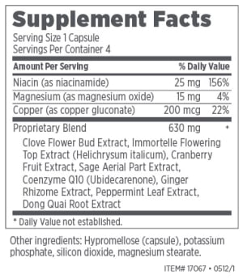
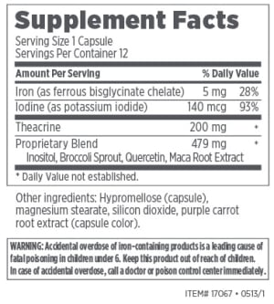

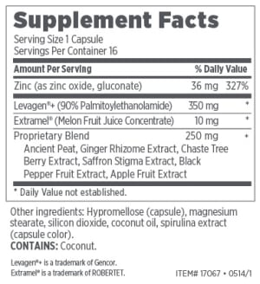

*These statements have not been evaluated by the Food and Drug Administration. This product is not intended to diagnose, treat, cure or prevent any disease.

