Menopause formula

WHAT MAKES OVA or Ova-m DIFFERENT?
Modere Ova™ is a new, patent-pending women’s health line formulated for women, by women.
Ova does more than target a collection of normal menstrual and menopausal symptoms. It supports optimal hormonal health — and it does this without hormones or soy isoflavones.

HOW DOES IT WORK?
It’s formulated based on emerging science that links normal menstrual and menopausal symptoms to fluctuating levels of key micronutrients in the body.
By syncing to your cycle, it targets the body’s responses to these fluctuating nutrients, providing optimal support when you need it most.

BENEFITS
FORMULATED WITH INGREDIENTS SHOWN TO:
- Support mood*
- Reduce mild hot flashes*
- Reduce night sweats*
- Reduce vaginal dryness*
- Support libido*
- Improve sleep health*
- Support cognitive health*
- Support cardiovascular health*
- Protect cells from oxidative stress*
- Support energy levels*

FEATURES
- Proprietary Estro-OS™ Complex
- Hormone- and soy isoflavone-free
- Clean label formula
- Gluten-free
- Dairy-free
- Non-GMO
†The ingredients Angelica gigas Nakai, Cynanchum wilfordii and Phlomis umbrosa together are shown to be more effective than soy isoflavones at improving normal menopausal symptoms and vaginal dryness.

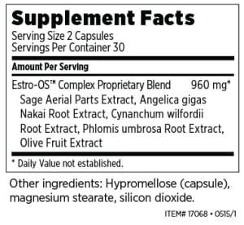

MENOPAUSE FORMULA
Angelica gigas nakai root extract
Reduce mild hot flashes, night sweats and vaginal dryness. Support libido and sleep health. Made from Angelica gigas Nakai.
Hypromellose
Capsule. Made from plant sources.
Cynanchum wilfordii hemsley root extract
Reduce mild hot flashes, night sweats and vaginal dryness. Support libido and sleep health. Made from Cynanchum
wilfordii Hemsley.
Phlomis umbrosa turcz. root extract
Reduce mild hot flashes, night sweats and vaginal dryness. Support libido and sleep health. Made from Phlomis umbrosa
Turcz.
Olive extract
Support antioxidant capacity and cardiovascular health. Made from olive (Olea europaea).
Sage aerial parts extract
Support cognitive health and help reduce mild hot flashes. Made from sage (Salvia officinalis).
Magnesium stearate
Flow agent. Made from natural sources.
Silicon dioxide
Flow agent. Made from natural sources..

DIRECTIONS:
Take two capsules once daily with food.

*These statements have not been evaluated by the Food and Drug Administration. This product is not intended to diagnose, treat, cure or prevent any disease.

