Getting started:

If you like what you see and you want to open an account and order when you get a chance here are the step-by-step instructions, you’ll want to take in order to get the $10 off coupon on your first order. (I am here to support you now and, in the future).

- Go to this link: by clicking it you will open your account and I want to ensure you get the $10 promo coupon. https://modere.co/3Yg7AZu
- Go to the top right of your screen and click on register as seen below: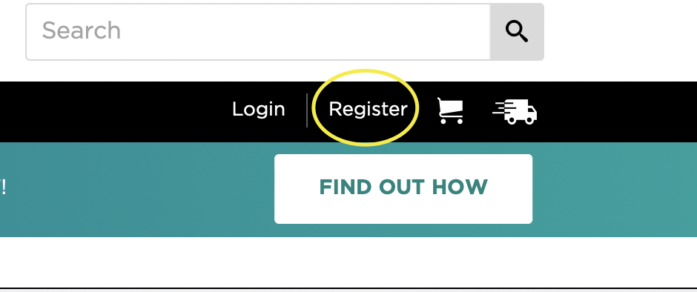
- If it asks you for the referral code (it may not through the link, I provided you with) you can use this: 9196051
- When you are completing your registration using the link or the code above, you should see this message confirming that you were referred by me and you’ll receive a shopping credit on your first order. It should look like this:
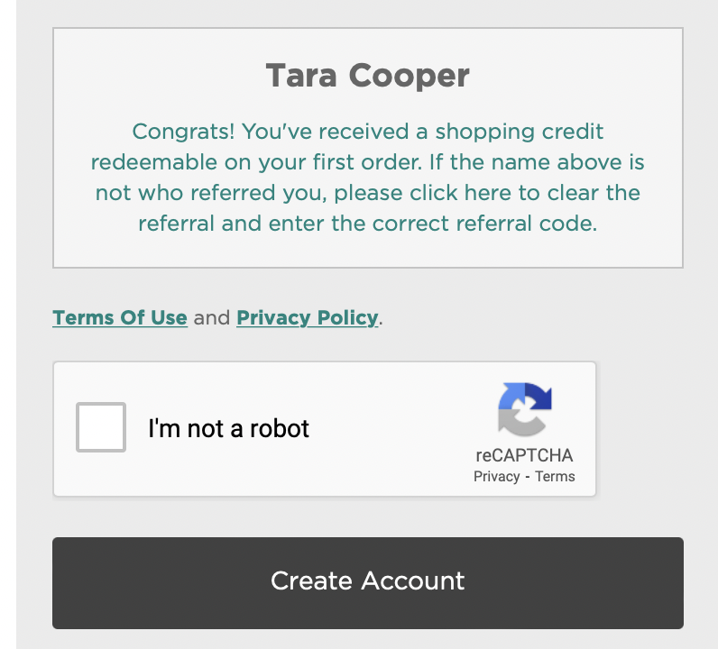
- PS. If you are uncomfortable giving your real Date of Birth, you can change it, they just want to be sure you are 18 years old or over to have an account.
- Once you’ve done these steps, you have successfully opened your account and now you can proceed to shop when you are ready.
- Mōdere has a Canadian shop found here (likely the same once you create your account)
- If you are specifically looking for the OVA (menstrual formula) or the OVA-M (menopause formula), you’ll need to go to the USA shop instead (after you’ve opened your account)
- USA shop is found here: https://www.modereglobalshop.com
- The product you are looking for may come up on the banner, but if not, here are the links for the two products – just make sure you select the one you want. (OVA – menstrual or OVA-M menopause.)

*tips: if you want to subscribe each month (easy to change or cancel) you will save more. Here is more info you may also find on the website.

GET ON THE VIP LIST
Level up your benefits and get even more savings and rewards every day when you upgrade to the Modere VIP List! Keep scrolling to find out how.

SAVE UP TO 15% with a monthly subscription and get your favorite clean label essentials delivered to your door!

GET FREE SHIPPING on orders with the subscription value of 8 or more items.

GET A $20 BONUS SAVINGS on month 2 of your subscription.

ENJOY EVERYDAY SAVINGS of 5% to 15% on all your purchases—even non-subscriptions. For example, if your subscription is eligible for 15% monthly savings, you’ll save 15% on all your everyday orders too!

GET UP TO AN ADDITIONAL 15% SAVINGS with a match on your monthly subscription discount as a thank you for your loyalty.

